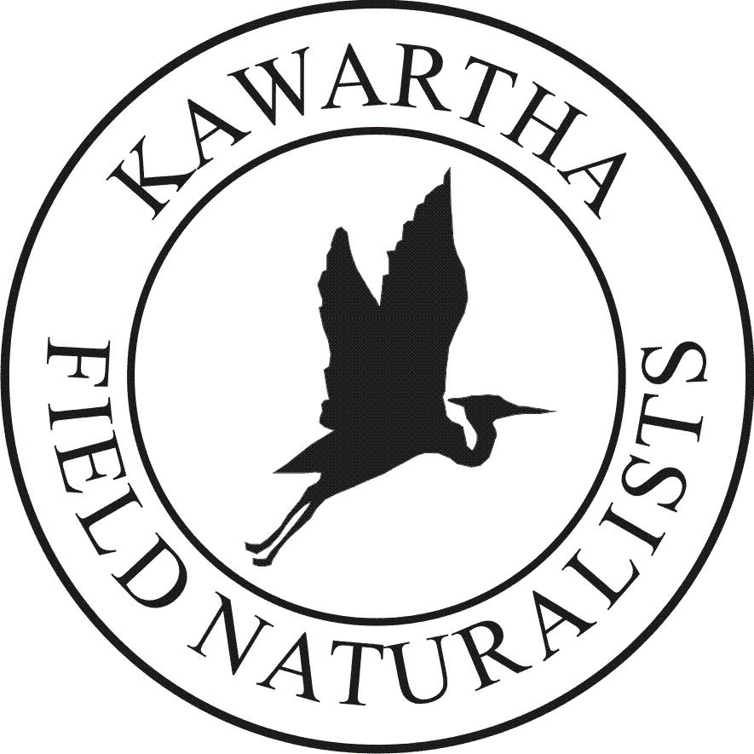

**Membership**

**a**pplication form

Memberships may be obtained by mailing completed form and cheque to

Kawartha Field Naturalists

133 Driftwood Village Dr.Coboconk,ON KOM 1K0

or etransfer to gerarda60@hotmail.com

# KAWARTHA FIELD NATURALISTS

www.kawarthafieldnaturalists.org

|  |  |  |  |  |  |  |  |  |  |  |  |  |  |
| --- | --- | --- | --- | --- | --- | --- | --- | --- | --- | --- | --- | --- | --- |
| CONTACT | | | | | | | | | | | | | |
| Name(s): |  | | | | | | | Home Tel: | | |  | | |
| Work Tel: | | |  | | |
| Address |  | | | | | | | Email(s): | | |  | | |
| MEMBERSHIP TYPE & FEE SCHEDULE | | | | | | | | | | | | | |
| Please make cheques payable to Kawartha Field Naturalists | | | | | | | | | | | | | |
| **Single Adult $20 □ Student (18 +) $15 □ Single Lifetime $250 □ Family Lifetime $350 □**  **Youth under 18 are free, when accompanied by an adult.** | | | | | | | | | | | | | |
| MAIN INTERESTS | | | | | | | | | | | | | |
| □ Birds | | | | □ Butterflies/Dragonflies | | | | | □ Botany (Wildflowers, ferns, trees) | | | | |
| □ Animals | | | | □ Insects | | | | | □ Geology | | | | |
| □ Reptiles and Amphibians | | | | □ Fish/Aquatic Life | | | | | □ Astronomy | | | | |
| □ Hiking | | | | □ Field Trips | | | | | □ Conservation | | | | |
| □ Mycology | | | | □ Other (specify) | | | | | | | | | |
| I (name) _________________________________ am knowledgeable in the following  areas _____________________________________________________ and would be prepared to  □ lead an outdoor session □ give a presentation □ prepare an article | | | | | | | | | | | | | |
| **I am interested in the following:**  □ Joining the KFN Executive □ Forming or sitting on a committee □ Working on field projects    □ Newsletter □ Helping with refreshments at meetings □ Helping with meeting setup/teardown  □ Please have a member of the executive call me | | | | | | | | | | | | | |
| AGE GROUP | | | | | | | | | | | | | |
| This information helps us to understand the needs of our members. If a family membership, please check for each adult | | | | | | | | | | | | | |
| □ Under 20 | | □ 20-29 | □ 30-39 | | □ 40-49 | □ 50-59 | □ 60-69 | | | □ 70-79 | | □ Over 80 | |
| DONATIONS | | | | | | | | | | | | | |
| Membership fees cover the general operating costs of the club, while other sources of revenue are needed to fund special projects, such as trail maintenance, ecological restoration, etc. You can assist the club by making a donation to help further our work in such areas. All donations are welcomed and gratefully received and any member of the executive will be happy to speak to you concerning donations. | | | | | | | | | | | | | |
| LIABILITY WAIVER | | | | | | | | | | | | | |
| In consideration of the Kawartha Field Naturalists (KFN) accepting this application, I hereby for myself, my heirs, executors, administrators and assigns  forever release and discharge the KFN, their officers, directors, servants and agents from any liability whatsoever arising from my participation in KFN activities, whether by reason of negligence of the KFN or its representative, or otherwise. I affirm that I am in good health, capable of performing the exercise required for field trips or other activities in which I participate, and accept as my personal risk the hazards of such participation. As a member of the KFN and/or as a parent/guardian of a member under 18 years of age, I have read and understand the above, accept its term on behalf of all of my underage children.  Signature______________________________________________Date_________________________________________ | | | | | | | | | | | | | |
| For administrative use only □ entered □ membership card issued. | | | | | | | | | | | | | |

GUESTS ARE ALWAYS WELCOME